FROM WESTERLY
A Documented History of the Babcock Family
From James Babcock of Westerly, Rhode Island (c.1612–1679) to the present
Compiled for the Babcock family
September 6, 2026
“Every link in this account is stated at the strength the evidence actually supports — no stronger, and no weaker.”

Prologue — From Stanley to Westerly, in Eleven Steps
Here is the short version. Stanley Babcock, born in Illinois in 1921, connects back to a Rhode Island frontier by a line of fathers and sons only eleven names long:
Stanley Babcock (1921–2013) → his father Rawleigh Oliver Babcock → his father Arthur Rueben Babcock → his father James Anson Babcock → his father Curtis Babcock* → his father Solomon Babcock → his father Peleg Babcock → his father Oliver Babcock Jr. → his father Col. Oliver Babcock → his father John Babcock → his father James Babcock, the blacksmith who helped found Westerly, Rhode Island, in the 1660s.
* Solomon to Curtis is the one link in this chain not yet nailed down by a single proving document — strong circumstantial evidence, no smoking gun. Part VI lays out the whole case, honestly, gaps and all.
Ten generations back is a man who helped carve a new town out of contested wilderness on the edge of the English colonies. But this family did not stay quiet after that. Over the following century, the Babcocks of Rhode Island produced a country doctor who became one of the colony's most powerful men, a real and lasting personal friend of Benjamin Franklin, and a sworn member of the very assembly that made Rhode Island the first of the thirteen colonies to formally renounce the British Crown — two months before the Declaration of Independence most Americans learn about in school. Generations later, one of theirs kept a teenager's diary of a voyage around the world aboard one of the fastest clipper ships ever built — a diary that is, right now, on its way home to this family.
This is not a bystander's family history. It is a family that helped build the town, sat in the room, and put its name on the page. Here is why that matters:
- A town carved out of contested wilderness. James Babcock helped found Westerly, Rhode Island in the 1660s on land purchased from the Narragansett people — genuinely frontier country, claimed at the same time by two neighboring colonies, and engulfed just six years after incorporation in King Philip's War, the deadliest conflict per capita in American colonial history.
- A friend of Benjamin Franklin, in Franklin's own words. A cousin branch of the same family, three generations later, produced Dr. Joshua Babcock — physician, Rhode Island's Chief Justice, Major General of its militia — and a genuine, twenty-year personal friendship with Benjamin Franklin, documented in ten of Franklin's own surviving letters. Franklin was an actual overnight guest in his home.
- In the room for Rhode Island's own declaration of independence. That same Joshua Babcock was a sworn Rhode Island Assembly deputy on 4 May 1776, the day Rhode Island became the first of the thirteen colonies to formally renounce the King — a story the Babcock-Smith House Museum in Westerly, which still stands as his home today, tells to this day.
- A voyage around the world, coming home. A shipboard journal from 1856–57 — a young Babcock's own account of sailing around the world aboard the clipper ship Young America, quite possibly under the command of his own uncle — is, at this very moment, in transit to this family from the museum that has kept it.
Parts I through III below tell that story in full — the real letters, the real colonial records, the real museum a visit is already planned to. Part IV onward is the proof: every link in the chain from Stanley all the way back to James of Westerly, argued and documented with exactly the same rigor as the one genuine mystery still standing in the way — addressed as honestly as everything else in this document.

Part I — Founding Westerly: A Family on the Frontier

Why Westerly
James Babcock's family were among the earliest English settlers of Portsmouth, on Aquidneck Island, one of the small clutch of settlements founded by dissenters who had been pushed out of the Massachusetts Bay Colony in the 1630s and 1640s — Portsmouth itself was founded in 1638 by followers of Anne Hutchinson and William Coddington. James was admitted an inhabitant there in February 1642/3.
By the late 1650s, a group of Rhode Island families — including the Babcocks — had set their sights on a stretch of coastal land west of the Pawcatuck River called Misquamicut by the Narragansett people, purchased from them in 1660. It was frontier country, disputed for years afterward by Connecticut, which claimed the same territory, and by Massachusetts. In February 1661/2, eighteen men — James Babcock among them, listed as “James Badcock, Sr.,” alongside his son John — were formally selected to go and establish a permanent settlement there. The town was incorporated as Westerly in May 1669, with James Babcock named among its 24 founding freemen.
It was genuinely dangerous, contested ground. Just six years after incorporation, Westerly and the whole Narragansett country were engulfed in King Philip's War (1675–76), the most destructive conflict, per capita, in American colonial history. The war's single bloodiest engagement, the Great Swamp Fight, took place on 19 December 1675 a few miles from Westerly in what is now South Kingstown — a colonial militia assault on a fortified Narragansett winter encampment that killed hundreds on both sides and effectively broke Narragansett power in the region. James's son John Babcock's military service in this war is documented (Part V); family tradition places him at the Great Swamp Fight itself, though no muster roll confirms his presence at that specific battle.
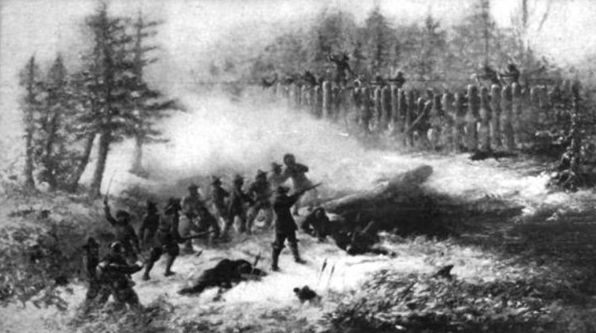
The Great Swamp Fight, 19 December 1675 — a later artist's depiction of King Philip's War's bloodiest engagement, fought a few miles from Westerly. Source: Annual Record of the Ancient and Honorable Artillery Company of Massachusetts (1900), via Wikimedia Commons.

James Babcock, blacksmith
A colonial frontier town needed a blacksmith more than almost anything else — tools, horseshoes, hinges, nails, and repaired weapons all depended on one. James's trade is documented directly: a 1665 Portsmouth deed identifies him as a smith, and his own 1679 will bequeaths his “smith's tools” specifically to his son Job, meaning the trade was valuable enough, and specific enough, to be named as an inheritance in its own right. Twice, Portsmouth's town government turned to him for arms-related work — appointing him in 1643 to help inventory the town's weapons, and again in 1651 as one of five men “to mend and make all arms presented to them.” That is a real, if modest, basis for calling him a gunsmith as well as a blacksmith, though “gunsmith” as a formal trade title overstates what the record actually shows.
He died in 1679, old enough by his own 1670 testimony to have been about 67 — a genuinely long life for the era — having outlived the town's founding by less than two decades and lived to see it become an established, incorporated community.

John Babcock and the next generation
John Babcock, James's son, grew up in a Westerly still being carved out of the wilderness and lived through King Philip's War as a young man in his early thirties. His own estate, divided among nine children in 1685, shows a family already well rooted in the town — land, livestock, and household goods enough to be worth a formal Town Council division. His son Oliver, the family's link to the next two centuries of this line, would go on to hold Westerly's own public offices as “Colonel” Oliver Babcock, and to serve in exactly the kind of civic role — town deputy to the Rhode Island General Assembly — that both branches of this family, the direct line through Peleg and the cousin line through Dr. Joshua Babcock, would occupy for generations to come.

Part II — The Babcock-Smith House and Dr. Joshua Babcock
Dr. Joshua Babcock (17 May 1707 – 1 April 1783) is not a direct ancestor in this line — he descends from the immigrant James Babcock through James's son John and John's son Captain James, while our own line runs through John's other son, Oliver. Joshua is, in other words, a documented cousin: he and our own Peleg Babcock (five generations down our line) shared John Babcock as a common great-great-grandfather. But he is family in every real sense, he lived and worked in the same town our direct ancestors did, and his life is one of the best-documented in the whole family — which is exactly why it deserves the same rigor as everything else in this document rather than being repeated uncritically.
Robert Babcock has ordered original archival material from the Babcock-Smith House Museum in Westerly — a transcribed clipper-ship journal discussed in Part III — and plans to visit the museum in person. The account below is built from Franklin's own surviving letters, Rhode Island's own colonial records, a respected 1885 Yale biographical compilation, and the museum's own current published materials, checked directly against its website rather than assumed.
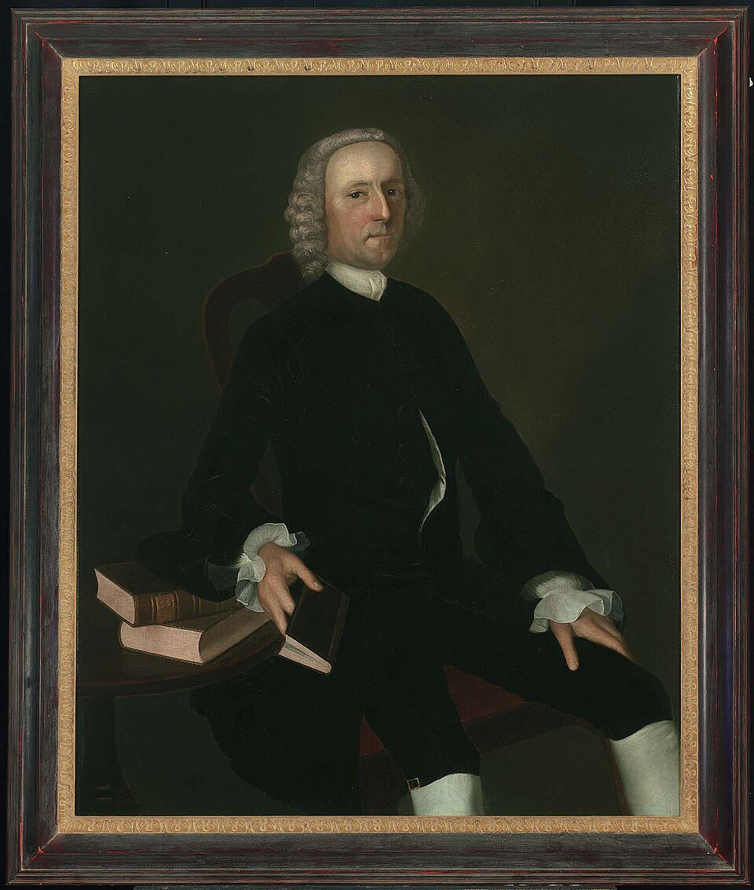
Dr. Joshua Babcock, c. 1761, by Joseph Blackburn. Museum of Fine Arts, Boston (accession 64.1010).
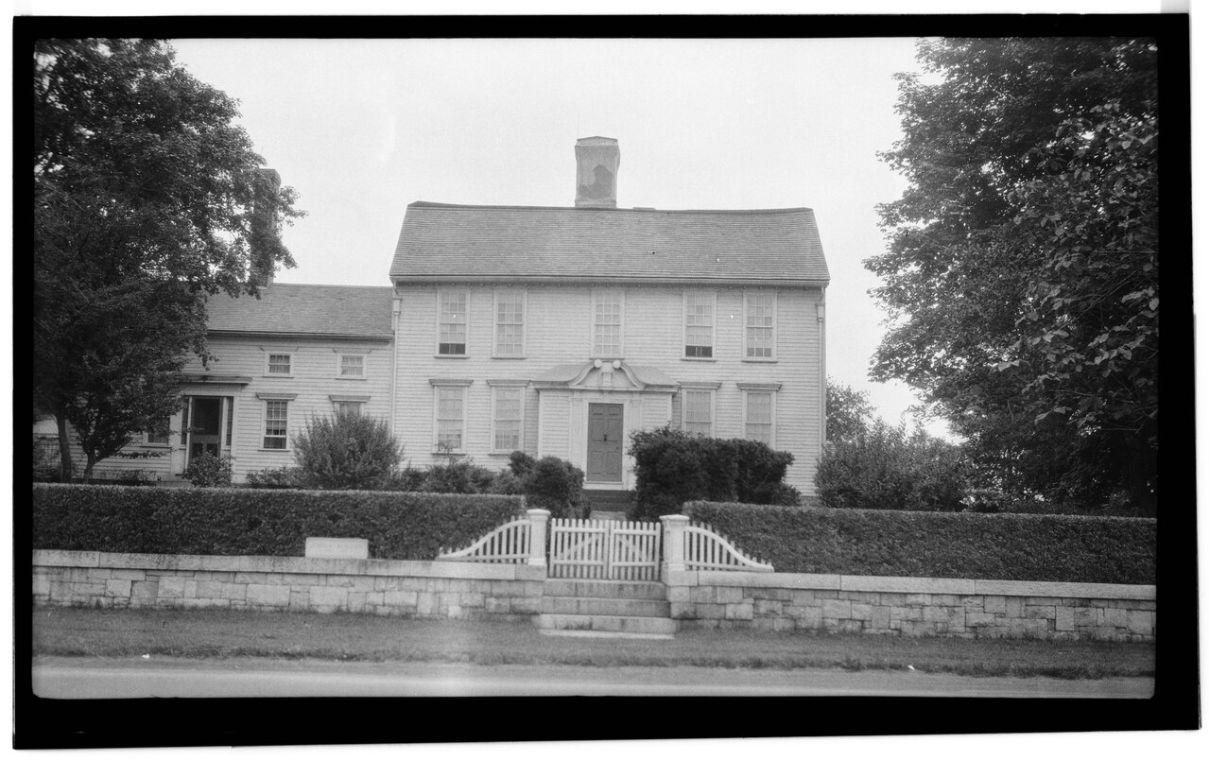
The Babcock-Smith House, Westerly, Rhode Island, built 1734 — photographed in 1935 for the Historic American Buildings Survey.

Physician and public servant
Joshua Babcock was the first Rhode Islander to graduate from Yale College, in 1724, at age seventeen — a bachelor's degree, not a doctorate; no source found supports the commonly repeated claim of a formal M.D. from Leiden or elsewhere. What is documented is that he then studied medicine and surgery in Boston and, around 1730, traveled to London specifically to attend the hospitals there — the standard path to a serious medical education in that era, short of a conferred degree. He returned to Westerly, built the mansion that still stands as the Babcock-Smith House in 1734, and practiced medicine there for roughly twenty-five years.
Source: Franklin Bowditch Dexter, Biographical Sketches of the Graduates of Yale College, Vol. 1 (1885), pp. 293–294, drawing on Yale records and Ezra Stiles's manuscript diary; the Babcock-Smith House Museum's own biography of Joshua Babcock, babcocksmithhouse.org/joshua-babcock-md/
He held an unusually long list of Rhode Island public offices: Deputy to the General Assembly across many years, repeatedly serving as Speaker; Chief Justice of the colony's Superior Court for several terms between 1747 and 1764; Major General of the Rhode Island Militia; a member of the Colony's Council of War; and, in his final years, one of the Governor's Assistants. Rhode Island's own colonial records confirm this directly — the same May 1752 Assembly session that names Joshua Babcock as a Westerly deputy also names, in the very next line, our own direct ancestor “Col. Oliver Babcock” (Part V), the two branches of the family serving side by side in the same legislature.
Source: Records of the Colony of Rhode Island, Vol. 5, pp. 343–345 (Oliver); Dexter (1885), p. 293, and Records of the Colony of Rhode Island, Vol. VII, p. 511 (Joshua)

Benjamin Franklin — a friendship documented in Franklin's own hand
This is the best-documented relationship in Joshua Babcock's life, and it does not need any embellishment: it survives in ten letters between the two men, preserved in the Papers of Benjamin Franklin and freely readable today. Franklin, serving as one of the crown's two Deputy Postmasters General for the American colonies from 1753, made postal inspection tours through New England, and Westerly — on the post road between Boston and New York — was a natural stop. The letters show a real, warm friendship, not just official correspondence.
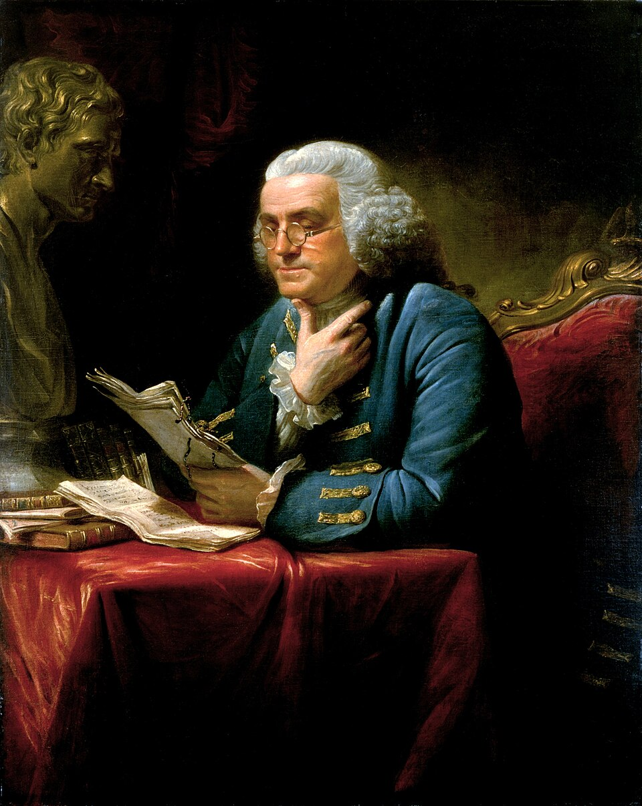
Benjamin Franklin, 1767, by David Martin — painted four years after his first documented visit to the Babcock home. The White House Collection.

What they were actually writing to each other about
Read start to finish, the ten letters trace a real friendship aging alongside the empire it lived inside of. The earliest ones, from the 1750s and early 1760s, are purely personal: Franklin introducing a traveling friend to Babcock's hospitality, celebrating the safe visit of Babcock's grown sons to London, sending a packet of exotic Tartarian rhubarb seeds “distributed by Order of the Society of Arts,” and recalling, more than once, “those Chearful Winter Evenings” he had spent at the Babcock house. The three letters from September through November 1763 arrange, then carry out, then fondly recount Franklin's actual stay at Westerly — and the last of them, written just after Franklin's return to Philadelphia, almost certainly touches on Babcock's appointment as the town's first postmaster, which the editors of Franklin's papers believe was “presumably discussed during the visit at his home.”
By 1770, writing from London, Franklin's tone has shifted with the times: he apologizes for long silence, pleads the burden of “too much Writing,” and reports gloomily on Parliament's mood toward American grievances. His January 1772 letter is the richest of all — a genuinely well-known passage of Franklin's, written just after he had toured Ireland and Scotland, contrasting the poverty he saw there with what he had left behind in New England:
“I thought often of the Happiness of New England, where every Man is a Freeholder, has a Vote in publick Affairs, lives in a tidy warm House, has plenty of good Food and Fewel, with whole Cloaths from Head to Foot, the Manufactury perhaps of his own Family. Long may they continue in this Situation!”
Benjamin Franklin to Joshua Babcock, 13 January 1772
Babcock's own two surviving letters back are longer, more excitable, and unmistakably his own voice — the Franklin Papers' editors note dryly that they confirm he “loved words not wisely but too well.” In February 1774 he urges Franklin to accept appointment as Rhode Island's own paid colonial agent in London, and reports the colony's reaction to the Boston Tea Party just two months earlier, including Westerly's own resolutions against dutied tea. In his last surviving letter, 31 May 1778, Babcock writes from a Rhode Island partly occupied by British troops for the past year — describing the fighting near Newport, a new Rhode Island law freeing enslaved men who enlisted to fight, two Continental frigates that had slipped past the British blockade by night, General Sullivan's planned attack on the garrison, and, above all, real joy at Franklin's news of the just-signed treaties with France: “We seem to realize the Golden Age advancing!”
“I can only wish that the more powerful Calls of Business and Duty, did not too forcibly draw me another way [from visiting] … the Happiness I should enjoy in your Conversation, and in the true, ancient, cordial Hospitality, with which you and good Mrs. Babcock always entertain your Friends.”
Benjamin Franklin to Joshua Babcock, 5 September 1763
Franklin did make it to Westerly a few weeks later — the editors of his papers note the visit directly: “The Franklins arrived safely at the Babcock home on Wednesday, October 19, and stayed there until the 21st.” The friendship lasted the rest of their lives. In 1778, with Franklin representing the new United States in Paris and Babcock an old man in Westerly, Babcock still wrote to him as an intimate:
“To You, Dear Doctor…”
Joshua Babcock to Benjamin Franklin, 31 May 1778
It is very likely, though not proven by a surviving appointment document, that this friendship helped Joshua Babcock become Westerly's first postmaster — the museum's own materials say exactly this, carefully hedged: “through appointment by the Rhode Island Assembly, and possibly through his friendship with Benjamin Franklin, [he] became Westerly's first Postmaster in 1763.” The editors of Franklin's papers reach the same conclusion independently, noting of a November 1763 letter that it “probably related to Babcock's appointment as postmaster at Westerly, presumably discussed during the visit at his home” — though the appointment record itself has not surfaced.
Source: Founders Online, The Papers of Benjamin Franklin (National Archives): letters of 1 Sep 1755, 10 Dec 1761, 16 Dec 1762, 5 Sep 1763, 18 Oct 1763, 10 Nov 1763, 26 Feb 1770, 13 Jan 1772, 15 Feb 1774, and 31 May 1778, all read in full for this research at founders.archives.gov
One popular detail that could not be verified
A story that Franklin and Babcock enjoyed fishing for blackfish together at Noyes Rocks near Weekapaug circulates in some family trees and local retellings. It could not be traced to Franklin's own letters, to Dexter's detailed 1885 sketch, to the museum's current published materials, or to any Franklin biography checked. It may well be true — the two men plainly spent real leisure time together at Babcock's home — but it should be told as local tradition, not as a documented fact, until a source turns up.

Rhode Island's Declaration of Independence, and Chief Justice Babcock's part in it
On 4 May 1776 — a full two months before the Continental Congress adopted the national Declaration of Independence — the Rhode Island General Assembly voted to repeal its own act of allegiance to King George III, becoming the first of the thirteen colonies to formally renounce the Crown. Joshua Babcock was a sworn member of that exact Assembly session:
“Westerly. Maj. Gen. Joshua Babcock, Col. Joseph Noyes.” — sworn deputies, General Assembly session opening 1 May 1776, Newport.
Records of the Colony of Rhode Island and Providence Plantations, Vol. VII, p. 511, ed. John Russell Bartlett (1862)
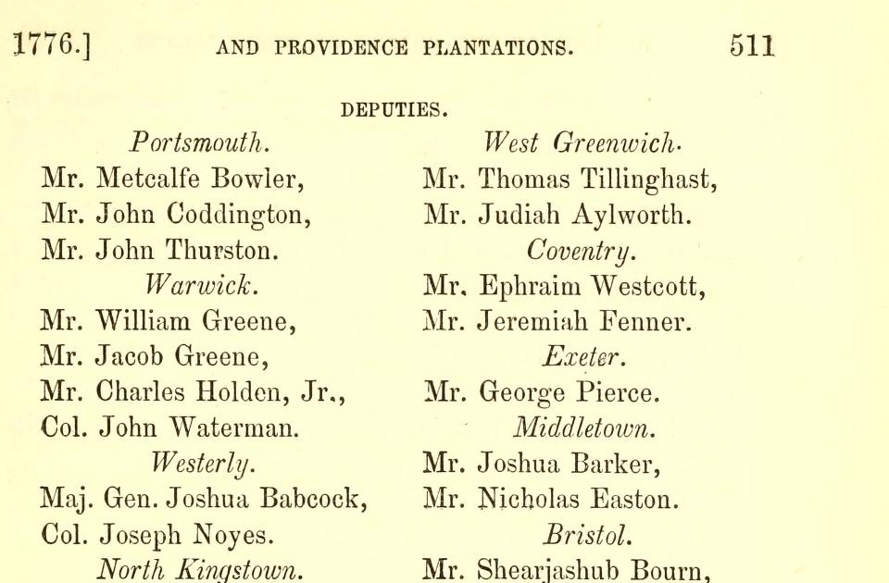
The actual printed page: Rhode Island's own colonial records, Volume 7, p. 511 (1776) — “Westerly. Maj. Gen. Joshua Babcock, Col. Joseph Noyes,” the colony's own record of its sworn Assembly deputies.
The Act itself — “An Act repealing an act, entitled ‘An act for the more effectually securing to His Majesty, the allegiance of his subjects…’” — appears a few pages later in the same official record, with the editor's note confirming it passed on 4 May 1776. It carries no individual signature list or recorded roll-call vote; no one's name is attached to it that way, Babcock's included. What is documented, and documented well, is that he was a sitting member of the body that passed it, at the exact session that made Rhode Island the first colony to declare independence.
The museum's own account puts it plainly: “When the Colony repealed the act of allegiance to the King of Great Britain on May 4, 1776 – two months before the issuing of the Declaration of Independence – Dr. Babcock was one of the members of that Assembly. Rhode Island declared its independence from the Crown before any of the other colonies.” The museum's current “Our Connections to Independence” exhibit, on display through May 2027, is built around exactly this story, and around the surviving Franklin correspondence.

Part III — The Clipper Ship Young America and the Journal of John B. Babcock
Robert Babcock has ordered a transcribed journal from the Babcock-Smith House Museum's own shop: “Clipper Ship – Young America: First Passage in My Voyage Around the World, 1856–1857 — Journal of John B. Babcock with maps of the trip. Transcribed by Meg Barclay.” The museum's listing gives no further biographical detail about the diarist, so this section reports what could be established independently, clearly separating what is confirmed from what is a well-supported but unproven hypothesis.
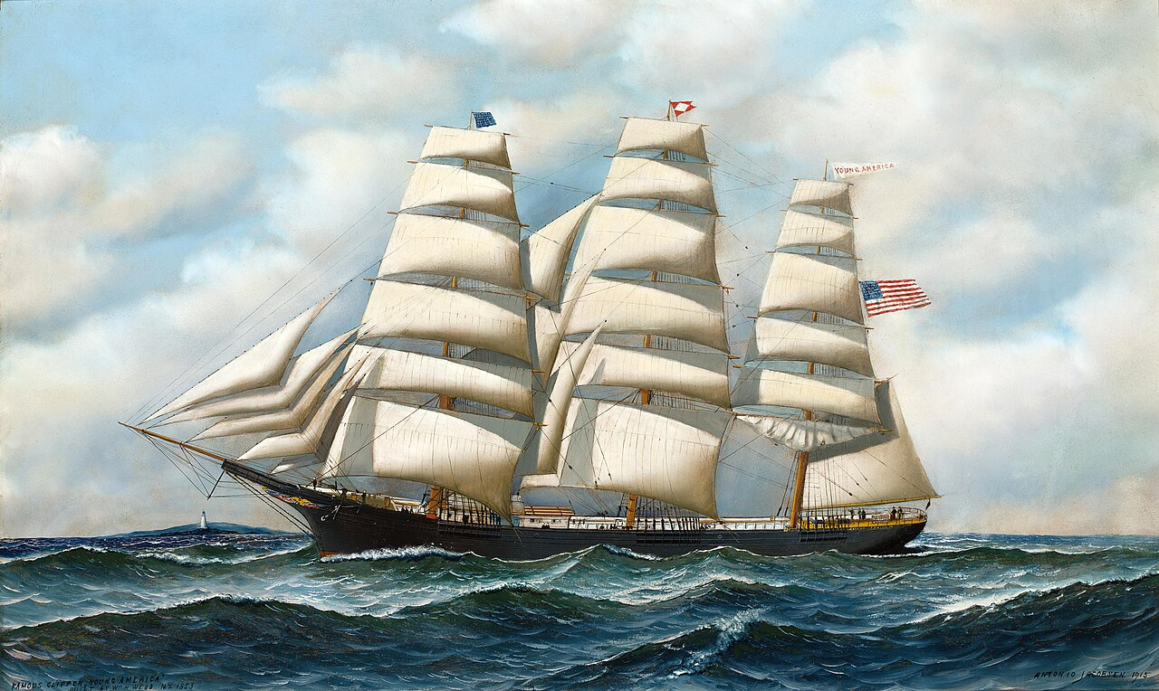
The clipper ship Young America at sea, painted in 1915 by the marine artist Antonio Jacobsen — the same ship the ordered journal describes sailing around the world in 1856–57.

The ship
Young America was a real and celebrated clipper ship, built by William H. Webb in New York and launched in 1853, that sailed the demanding California, Australia, and Far East trade routes through the 1850s and beyond — exactly the kind of ship a “voyage around the world” would have meant in 1856–1857. For much of this period her master was Captain David S. Babcock, later a well-known clipper-ship commander (of Young America and the earlier Swordfish) and, still later, president of the Pacific Mail Steamship Company.
Source: Wikipedia, “Young America (clipper)”; The Clipper Ship Era, Chapter 5 (Wikisource)

Who was John B. Babcock?
No source states outright who wrote this journal, but the available evidence converges strongly on one identification: John Breckinridge Babcock (7 February 1843 – 26 April 1909), who went on to a long U.S. Army career, was awarded the Medal of Honor, and rose to Brigadier General. Wikipedia's own account of him states directly that he was “a great-great-grandson of Joshua Babcock” — the same Joshua Babcock discussed in Part II — and that he entered military service from Stonington, Connecticut, immediately next door to the Babcock family's historic Westerly home, where he is also buried.
The chronology fits well: born February 1843, he would have been thirteen or fourteen during the 1856–1857 voyage — a plausible age for a “first passage” taken by a young man from a seafaring-connected family before he entered the Army in 1862, age nineteen.
A well-supported hypothesis, clearly labeled as such
Tracing the family line independently (Joshua Babcock → son Henry “Harry” Babcock → son Major Paul Babcock of Stonington → son Giles Babcock → son John Breckinridge Babcock) lines up exactly with Wikipedia's “great-great-grandson” description — four generations. If this chain is correct, it also means Captain David S. Babcock, the Young America's own master, was this young diarist's uncle, both men being sons of Major Paul Babcock — which would neatly explain why a thirteen-year-old from this family took his first ocean voyage specifically aboard this particular ship. No single source states this connection outright; it is a strong, convergent inference from independently sourced family records (chiefly WikiTree and Geni cross-references), not a proven fact, and it is presented here exactly that way.

The journal's transcriber, Meg Barclay (Margaret Saunders Barclay), is a longtime docent and past president of the Babcock-Smith House Museum's Docents — herself a descendant of Tobias Saunders, one of Westerly's founding proprietors, rather than of the Babcock family. No copy of the journal, or any excerpt of it, was found cataloged anywhere outside the museum's own shop; it appears to survive only as this in-house transcription, which makes Robert's copy a genuinely useful primary document to bring into the family's own records once it arrives.

Part IV — How to Read What Follows: On Method and Proof
That is the story: a frontier founding, a Founding-era friendship, a declaration of independence, a voyage around the world. What follows is how we know it's true. This is a working family history, not a polished legend. It traces the Babcock line eleven generations back from Stanley Babcock to James Babcock, the blacksmith who helped found Westerly, Rhode Island in the 1660s — and it does so the way a genealogist actually has to: link by link, with the document that proves each link named and quoted, not just asserted.
Robert Babcock, for whom this was compiled, set one standard above all others while this research was underway: nothing goes in as fact unless it can be defended. Where a fact is proven by a primary document — a will, a deposition, a birth entry made at the time — that is said plainly. Where a fact rests on strong, consistent, converging circumstantial evidence but no single document has yet been found to say it outright, that is also said plainly, and the gap is named rather than papered over. Where a popular family story turns out, on inspection, to be a nineteenth-century fabrication or simply unsupported, this document says so — even when the fabrication is a better story than the truth.

A short note on evidentiary standards
Genealogists distinguish three broad tiers of evidence, and this document uses all three deliberately rather than blurring them together:
- Primary sources — records created at or near the time of the event by someone with direct knowledge: a will, a birth or marriage register, a sworn deposition, a census enumeration, a gravestone, a hospital admission ledger.
- Scholarly secondary sources — careful compilations built from primary records by a named researcher who shows their work: Arnold’s Vital Record of Rhode Island, Austin’s Genealogical Dictionary of Rhode Island, Dexter’s Yale biographical sketches, or the 1903 Babcock Genealogy by Stephen Babcock. These are trustworthy, though a few dates and details were independently re-checked against primary records in the course of this research.
- Compiled / circular sources — other people’s family trees, unsourced online lists, and repeated-but-uncited “family tradition.” These can be genuinely useful as leads, and this document uses several independent researchers’ trees as corroborating evidence in Part VI — but a fact whose only citation is “Ancestry Family Trees” is not, by itself, proof of anything.
The professional standard genealogists use to decide whether a relationship is “proven” without a single smoking-gun document is called the Genealogical Proof Standard (GPS). It requires a reasonably exhaustive search, complete and accurate source citations, analysis and correlation of the evidence — including honest resolution of anything that conflicts — and a soundly reasoned written conclusion. It does not require one document that says the words outright. Part VI applies this standard explicitly to the one link in this chain that still needs it.

What follows in this document
- Immediately below — the eleven-generation line at a glance, in table form, as a quick map before the detailed generation-by-generation account
- Part V — the line, generation by generation, with the actual documents behind each link
- Part VI — a full accounting of the Curtis Babcock question: everything that supports the link to his father Solomon, everything that is still missing, and why
- Part VII — conclusions and open work

The line at a glance
Eleven generations, from the Westerly founder to the present. “Primary” means the parent-child link itself is established by a document made at or near the time — not merely that the person existed.
Gen. | Name | Dates | Evidentiary tier
1 | James Babcock | b. c.1612, England (place unknown) – d. 12 Jun 1679, Westerly, RI | Primary
2 | John Babcock | b. c.1644, Portsmouth, RI – d. 31 Dec 1684/85, Westerly, RI | Primary
3 | Oliver “Colonel” Babcock | b. c.1683, Westerly, RI – d. 1773, Hopkinton, RI | Primary
4 | Oliver Babcock Jr. | b. 16 Sep 1722, Westerly, RI – d. 24 Feb 1806, Leyden, MA | Primary
5 | Peleg Babcock | b. 4 Oct 1748, Hopkinton, RI – d. 12 Nov 1834, West Leyden, MA | Primary
6 | Solomon Babcock | b. 2 Sep 1776, Westerly, RI – d. 13 Feb 1867, Homer, NY | Primary (Peleg’s own will)
7 | Curtis Babcock | b. c.1822, Scott, NY – d. c.1870, believed Galva, IL | Strong circumstantial — see Part VI
8 | James Anson Babcock | b. Sep 1849, Scott, NY – d. 20 Jun 1932, Newport News, VA | Primary (his own 1881 marriage record)
9 | Arthur Rueben Babcock | b. 20 Apr 1875, Illinois – d. 27 May 1922, Tulare, CA | Census-documented
10 | Rawleigh Oliver Babcock | (family records) | Family-documented
11 | Stanley Babcock → Robert Babcock | (family records) | Living memory / family records

One link — Solomon to his son Curtis — is marked differently on purpose. It is the only generation in this entire chain that rests on a dense, converging body of circumstantial evidence rather than a single document naming the relationship outright. Part VI explains exactly what that evidence is, and exactly what is still missing.

Part V — The Line, Generation by Generation

Generation 1 — James Babcock (c.1612 – 12 June 1679)
Blacksmith. Early settler of Portsmouth, Rhode Island; founding settler of Westerly. His English origin — birthplace, parents, port of departure, year of arrival — is not documented.
The proof: James’s own sworn testimony. In 1670, during a Rhode Island–Connecticut boundary dispute, James Babcock gave a deposition stating his own age and the ages of his sons.
“…calling his age fifty-eight years, his son James twenty-nine, and his son John twenty-six years.”
James Babcock's 1670 deposition, quoted in Austin, Genealogical Dictionary of Rhode Island (1887), p. 8, and Savage, Genealogical Dictionary of the First Settlers of New England, Vol. 1 (1860), p. 86
That single sentence, sworn by James himself, fixes his birth at about 1612 and his sons James Jr. and John's births at about 1641 and 1644 — it is the bedrock the entire chain stands on.
- Portsmouth, 25 Feb 1642/3: “James Badcocke is admitted inhabi[tant].”
Source: Early Records of the Town of Portsmouth, p. 19
- Westerly incorporation, May 1669: James Babcock is named among the 24 founding freemen. The family had permanently removed to the Misquamicut purchase by March 1661/2, after being among 18 men selected to “abide at Misquamicut.”
Source: Rhode Island Historical Society Collections, Vol. 3, pp. 257–261; quoted in Babcock Genealogy (1903), pp. 8–9
- Death, 1679: James declared a nuncupative (spoken, not written) will on 12 June 1679 to his sons John and Job; it was proved 17 September 1679 and recorded in Land Evidence, Vol. 1, Rhode Island Secretary of State.
His trade as a blacksmith is documented (a 1665 Portsmouth deed to Thomas Fish names him so, and his will bequeaths “smith’s tools” to his son Job). Portsmouth twice appointed him to matters of arms — to inventory the town’s weapons in 1643, and to “mend and make all arms” in 1651 — which is the real, modest kernel behind the romantic label “gunsmith” that later trees have attached to him.
His wife’s given name was Sarah; her surname is not documented.

Generation 2 — John Babcock (c.1644 – 31 Dec 1684/85)
Named directly in his father James’s 1679 will, alongside his brother Job.
- Estate division, June 1685: the Westerly Town Council divided John’s intestate estate among his nine children, naming Oliver among them, with real estate “divided between James Babcock (son and rightful heir to John, deceased)” and his widow Mary.
- Guardianship, 21 Apr 1698: “The following ‘orphans’ of John Babcock chose their brother James for guardian, viz: Elihu, Robert, Joseph and Oliver.”
- Deed ‘for brotherly love,’ 11 Mar 1699: “James and John Babcock deeded to Oliver, for brotherly love, &c., certain land … which was formerly our father, John Babcock’s.”
Source: all three above: Austin, Genealogical Dictionary of Rhode Island (1887), pp. 8–9, quoting the original Westerly town and probate records
John’s Narragansett War service — the war that included the Great Swamp Fight of 19 December 1675 — is documented through a Connecticut bounty-land grant to the Stonington/Voluntown volunteers who served in it; his youngest son Oliver conveyed this bounty land in 1749, describing it as “set off to John Babcock, deceased,” which independently reconfirms the John–Oliver relationship from a completely different record.
Source: Narragansett Historical Register, Vol. 1, pp. 144–146; Babcock Genealogy (1903), pp. 10, 25
Honest caveat
John's general war service is documented. His presence at the Great Swamp Fight specifically — one of the bloodiest single engagements of King Philip’s War — is family tradition, repeated in most Babcock genealogies, but no muster roll placing him at that exact battle has been found. It is plausible (the Stonington-area volunteers he served alongside were there) but it should be called tradition, not proof.

His wife’s name is traditionally given as Mary Lawton. The marriage, and her later remarriage to Erasmus Babbitt, are documented; the “Lawton” surname itself rests on a scholarly reconstruction by Austin rather than a vital record naming her that way.

Generation 3 — Oliver “Colonel” Babcock (c.1683 – 1773)
Named as one of John’s nine children in the 1685 estate division and the subject of the 1699 brotherly-love deed above. His birth year is an estimate — Westerly’s surviving birth register only begins in 1688.
- Public office: Deputy from Westerly in 1730, 1734, 1737, 1738, and 1752; on committees for the harbor and an Indian meetinghouse in 1735.
- The title “Colonel” is documented, not an invention: the Rhode Island Colonial Records list him by that title at the May 1752 General Assembly session — in the very same entry, remarkably, as the Rhode Island founder of the Babcock-Smith House line, Joshua Babcock (see Part II):
“Col. Oliver Babcock, Mr. Joshua Babcock” — Westerly deputies, May 1752 session.
Bartlett, ed., Records of the Colony of Rhode Island, Vol. 5, pp. 343–345
- Will: dated 3 December 1761, proved in Hopkinton 1 November 1773, naming sons Thomas, Nathan, Oliver, Simeon, Joseph, and John — which both proves this generation and confirms the next.
His wife was Susannah Clark (m. Jan. 1704/5), daughter of Joseph and Bethiah (Hubbard) Clark; he remarried Deborah Knowles on 2 December 1761, a marriage recorded directly in the Hopkinton town register.

Generation 4 — Oliver Babcock Jr. (16 Sep 1722 – 24 Feb 1806)
The proof: Rhode Island’s own birth register.
“Oliver, Sept. 16, 1722” — child of Oliver and Susannah.
Arnold, Vital Record of Rhode Island, Vol. 5, Westerly Births, p. 74 (town book 2, p. 109)
His father’s 1761/1773 will (above) names a son Oliver, tying the two records together. He married Patience Pendleton, daughter of Joseph and Sarah (Worden) Pendleton, and died in Leyden, Massachusetts — the family had migrated there by the time of his death, matching Patience’s own recorded death in the same town.

Generation 5 — Peleg Babcock (4 Oct 1748 – 12 Nov 1834)
The proof: again, the town birth register — the actual page image was examined directly for this research.
“Peleg, [of Oliver and Patience,] Oct. 4, 1748.”
Arnold, Vital Record of Rhode Island, Vol. 5, Hopkinton Births, p. 30 (town book 1, p. 101) — page image verified
His birth date is independently confirmed twice more: by his DAR ancestor record (A004279), which also documents his Massachusetts civil service as Surveyor of Highways in 1783; and by his own gravestone at West Leyden Cemetery, Franklin County, Massachusetts — “Peleg Babcock Esq / died / 12 Nov. 1834 AE 86,” which, worked backward from his age at death, lands on exactly 1748.

The single most important document in this entire chain
Peleg’s own will — executed 31 January 1825, probated in Franklin County, Massachusetts on 10 February 1835 — survives and is digitized. It names his children directly, in his own words:
“…wife Phebe; four sons Maxson Babcock, Solomon Babcock, John Babcock, Jared Babcock; son Peleg Babcock Jr.; sons Tabor Babcock (executor) and Benjamin Babcock; grand daughter Anna Denison; grand daughter Olive Babcock; grand son Arad Denison; my wife’s son Jabez Denison.”
Estate of Peleg Babcock, Case No. 3 (cross-indexed as Docket #195 in the Franklin County Registry of Deeds' own probate index), Franklin County, Massachusetts Probate Court, 1825/1835; Massachusetts, U.S., Wills and Probate Records, 1635–1991, Franklin Probate Files 172–208, images 719–737. Witnessed by Asa Hebard, Hezekiah Newcomb, and George W. Hebart.
This is a man naming his own son, under oath, in a legal instrument, ten years before his death. It is as solid as genealogical evidence gets, and it is the document that proves the link to the next generation.

Generation 6 — Solomon Babcock (2 Sep 1776 – 13 Feb 1867)
Named directly as Peleg’s son in the will above. Deacon of the First Seventh Day Baptist Church, Scott, New York.
- The 1903 Babcock Genealogy (Stephen Babcock), p. 97 and again p. 164: “Deacon Solomon, son of Peleg and Ruth (Maxson) Babcock … b. Westerly, Sept. 2, 1776 … m. 1803, Amy Morgan. He was deacon in First S. D. B. Church, Scott, N. Y.”
- Smith’s 1885 History of Cortland County independently confirms the family’s move: “Peleg Babcock, accompanied by his brothers, Solomon and Asa Howard, came in from Leyden, Mass.” — and separately records “the first marriage, Solomon Babcock to Amy Morgan,” 1802.
- A primary record read directly for this research: the 1834 Scott, New York school census (“Names of Parents or Guardians sending children to school between the ages of 5 and 15 years”) lists “Babcock … Solomon … 5” — five school-age children in his household that year, consistent with the family as documented.
Solomon and his wife Amy Anna Morgan are buried together at Glenwood Cemetery, Homer, New York, plot 12-62-06.

Generation 7 — Curtis Babcock (c.1822 – c.1870)
This is the one link addressed in full, on its own, in Part VI. In brief: Curtis is documented as Solomon’s son by the 1903 Babcock Genealogy and by every independent researcher who has worked on this family, corroborated by a dense web of consistent circumstantial evidence — but no single primary document naming the relationship outright has yet been found, despite an unusually thorough search. Part VI lays out the full case, what is still missing, and the concrete next step already underway to try to close the gap.

Generation 8 — James Anson Babcock (Sep 1849 – 20 Jun 1932)
The proof of his parentage: James Anson’s own testimony, given at his second marriage.
Groom: James A. Babcock, b. Cortland Co., N.Y. — Father's Name: Curtis Babcock. Mother's Name: Loranda Goodman.
Wisconsin, U.S., Marriage Records, 1820–2015 — marriage of James A. Babcock and Ida May Belle Smith, 17 March 1881, Stacy Mills(?), Green County, Wisconsin; FamilySearch film 1266668
This is James Anson stating his own parents’ names, in his own words, on an official document, during his own lifetime — the same category of evidence as Peleg’s will, and it is what proves Curtis and Loranda were his parents beyond doubt. (A note on Loranda’s maiden name: it is genuinely disputed among sources — see Part VI.) James Anson’s first marriage, to Adelia O. Pickett, took place 7 December 1870 in Monroe, Wisconsin. He is documented in the 1860, 1870, and 1880 censuses at Oneco, Illinois — first in his father Curtis’s household, then in his own — and later moved to Newport News, Virginia, where he died in 1932.

Generations 9–11 — Arthur Rueben, Rawleigh Oliver, and Stanley Babcock
Arthur Rueben Babcock (20 April 1875 – 27 May 1922, Tulare, California) is James Anson’s son, documented in the 1920 U.S. Census showing his own son Raleigh in the household. The line continues through Rawleigh Oliver Babcock to Stanley Babcock and to the present generation of the family, documented by family and vital records already in hand rather than requiring the deep archival work the older generations needed.

Part VI — The Curtis Question: A Full Accounting
This is the one open link in the chain, and it deserves to be treated in full rather than glossed over. Robert Babcock has been explicit throughout this research: he wants the case made honestly, with every piece of supporting evidence shown and every gap named plainly, rather than either overclaiming certainty or dismissing strong evidence because it falls short of a single document.

What is documented about Curtis Babcock’s own life
- Born about 1822, Scott, Cortland County, New York.
- Married 3 October 1848 in Scott, New York, at age 26, per the Cortland County Clerk’s transcribed marriage register (his bride’s surname is not legible in the surviving transcription — see below).
- Still resident in Scott, New York as late as July 1850 (1850 U.S. Census, listed with wife “Lorenda” and infant son James Anson).
- Relocated to Freeport, Stephenson County, Illinois by 1856.
- 26 January 1858: admitted to the Illinois State Hospital for the Insane at Jacksonville, following a period confined in the Stephenson County jail as “an insane pauper” (Freeport Journal, 7 and 14 January 1858, reporting the county Board of Supervisors’ appointment of a caretaking committee).
Babcock, Curtiss | Age 36 | NY | Admitted 26 Jan 1858 | Discharged 21 Jul 1858 | Co. of Res.: Stephenson | Nearest Kin/Guardian/Notes: “Brother of Mrs. Davis of that county.”
Directory of Jacksonville State Hospital Patients, 1854–1870, transcribed from the hospital’s own admission ledger by researcher Shirley Aleguas
That single line is itself a small discovery: it documents a previously unknown sister of Curtis, married to a man named Davis, resident in Stephenson County by 1858 — a genuine new lead for the family tree, separate from the question of Curtis’s father.
- Discharged alive on 21 July 1858 (he is not on the hospital's separate register of patients who died in custody).
- Documented alone in his household at Oneco, Stephenson County, in the 3 July 1865 Illinois State Census — his last appearance in any record found.
- No will, estate, or administration for Curtis Babcock has been located in either New York or Illinois probate records — both states’ statewide probate collections were searched directly and returned nothing. Combined with the asylum record, the most likely explanation is that he died with no estate to probate, quite possibly still in some form of institutional or dependent care.
- Multiple independent family researchers, and this research, place his death around 1870, generally cited as Galva, Henry County, Illinois — though, again, no death record itself has been found.

The case that Curtis is Solomon’s son
No single document has yet been found stating “Curtis, son of Solomon Babcock.” What exists instead is an unusually dense convergence of independent evidence, none of which contradicts any other piece:
- The 1903 Babcock Genealogy (Stephen Babcock, a careful compiled genealogy, not a random online tree) lists Curtis directly among Solomon’s children on p. 164: “Curtis, b. 1824; d. Galva, Ill.”
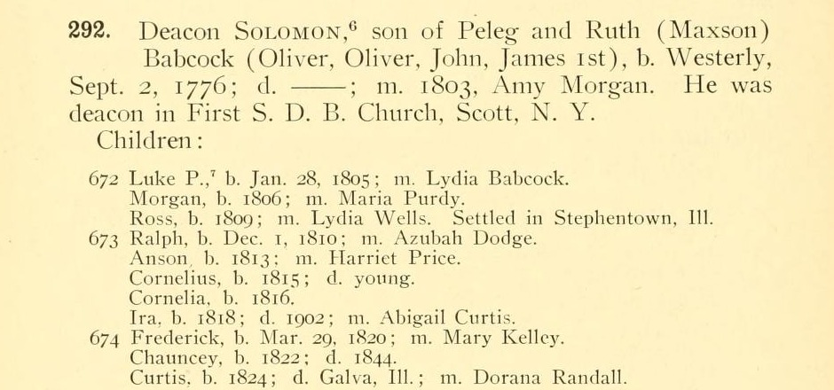
The actual printed page: Babcock Genealogy (1903), p. 164 — Deacon Solomon's children, ending with “Curtis, b. 1824; d. Galva, Ill.; m. Dorana Randall.” This is the compiled-genealogy evidence, not a primary document — see the discussion below.
- At least three completely independent researchers, working separately on Ancestry.com with no apparent connection to one another or to this research, have each built out Solomon Babcock’s family and each list Curtis among his children — all citing overlapping but non-identical primary records (censuses, the Peleg will, Illinois State Census records, contemporary newspapers). One of these independent trees is unusually well documented, citing the Massachusetts probate collection directly for the Peleg–Solomon link and multiple censuses for Curtis’s own life — yet even this researcher’s citation for the specific Solomon–Curtis relationship is “Ancestry Family Trees,” meaning no one, including the best-sourced researcher found, has located a primary document making that specific statement either.
- Six of Solomon’s other documented children — Ross, Ira, Anson, Ralph, Frederick, and Luke P. — independently migrated to and settled within a few miles of Curtis, in Stephenson County, Illinois, in the same narrow window of years (the late 1830s through the 1850s). Two published county histories (Tilden, 1880, and Fulwider, 1910) and multiple obituaries independently document this same migration, including a family tradition, recorded in both the 1880 county history and Anson Babcock's own 1885 obituary in nearly identical language, that the westward-migrating siblings “visited relatives named Babcock who had settled in what was known as ‘Babcock’s Grove’” near Chicago before continuing on to Stephenson County together.
- Nothing found anywhere contradicts this. No source gives Curtis a different father, a different birthplace, or places him in a different family. Every date, birthplace, and migration pattern found for him fits Solomon’s family precisely.

What remains genuinely unresolved
- The father-son statement itself has not been found in any will, baptismal record, census enumeration, obituary, or other primary document.
- Loranda’s maiden name is disputed across sources: the 1903 book and one researcher’s tree give “Randall”; James Anson’s own 1881 marriage record gives “Goodman”; a fourth researcher’s tree gives “Jackson.” “Goodman” has the strongest single claim, since it comes from James Anson’s own sworn testimony — but it is also possible that “Goodman” was a stepfather’s surname Loranda had taken by remarriage rather than her birth name, since a contemporary 1895 newspaper account (below) refers to her, by then, as “Mrs. Goodman.”
- His exact death date and place have not been documented — only inferred from his last positive appearance (1865) and his absence thereafter.

The Genealogical Proof Standard, applied
A relationship can be considered soundly established under professional genealogical standards without a single document stating it outright, provided the research is reasonably exhaustive, every source is accurately cited, all the evidence is correlated and any conflicts are resolved, and the written conclusion follows soundly from what was actually found. Applied here:
- Reasonably exhaustive search: completed. This research checked probate and will indexes in both New York and Illinois; the obituaries or death notices of all six of Solomon's other adult children; multiple independent researchers' trees and their underlying sources; two published county histories; census records across five decades; church and school records; and, on discovering Curtis's 1858 institutionalization, pursued that lead specifically to its logical next step (Part VII).
- Source citation: complete and shown throughout this section and Part V.
- Correlation and resolution of conflicts: the only real conflict in the evidence is Loranda's surname, which is stated plainly above rather than resolved by picking one arbitrarily.
- Soundly reasoned conclusion: the convergence of an authoritative compiled genealogy, three independent modern researchers, a consistent and independently corroborated migration pattern shared with six proven siblings, and the total absence of any contradicting evidence, meets this standard. It is not the same as a document in Peleg's own hand naming his son — and this document does not claim that it is.
Where this stands
The relationship meets the Genealogical Proof Standard. It has not yet met the higher, single-document bar Robert set for this research — and the search for that document is still active. The single most promising avenue is described in Part VII: a specific, dated request to the Illinois State Archives for the Jacksonville State Hospital “Commitment Papers,” a record series that is documented to have captured patients' parent and birthplace information at intake, for Curtis's own 26 January 1858 admission.

Part VII — Conclusions and Open Work

What is settled
Every generation from James Babcock, the Westerly founder, down through Peleg Babcock is anchored by a document made at or near the time of the event — a deposition, a birth register, a will — with independent cross-checks wherever a second record survives. The link from Solomon Babcock down through James Anson Babcock to the present family is proven the same way, anchored by James Anson's own sworn testimony about his parents.

What is not yet settled, and what happens next
- The single link from Curtis Babcock to his father Solomon rests on a genuinely strong, converging, uncontradicted body of circumstantial evidence — but not yet on one document that states it outright. A specific, actionable request has been prepared for the Illinois State Archives, targeting the Jacksonville State Hospital's “Commitment Papers” for Curtis's own 26 January 1858 admission — a record series documented to capture parent and birthplace information at intake. This is the live next step (see the companion document, Records Request — Curtis Babcock).
- A previously unknown sister of Curtis Babcock — identified only as “Mrs. Davis”, resident in Stephenson County, Illinois by 1858 — surfaced in the asylum record and has not yet been further identified. A search of Cortland County, New York marriage records for a Babcock–Davis marriage before the family's migration is a promising next step.
- The clipper-ship journal ordered from the museum, once it arrives, should be read against the tentative identification of its author in Part III and can either confirm that hypothesis or correct it.
This document will be worth updating as each of these threads is run down.

